Varoon Kumar

25k-0617

**PF LAB 07 (Remaining task)**

**Question 04**

* **Code**

#include <stdio.h>

int main() {

int n;

printf("Enter number of sales records: ");

scanf("%d", &n);

int arr[100];

printf("Enter product IDs:\n");

for (int i = 0; i < n; i++)

scanf("%d", &arr[i]);

int maxCount = 0, mostFreq = arr[0], count = 1;

for (int i = 1; i < n; i++) {

if (arr[i] == arr[i - 1])

count++;

else

count = 1;

if (count > maxCount) {

maxCount = count;

mostFreq = arr[i];

}

}

printf("\nMost frequent product ID: %d", mostFreq);

return 0;

}

**Output**

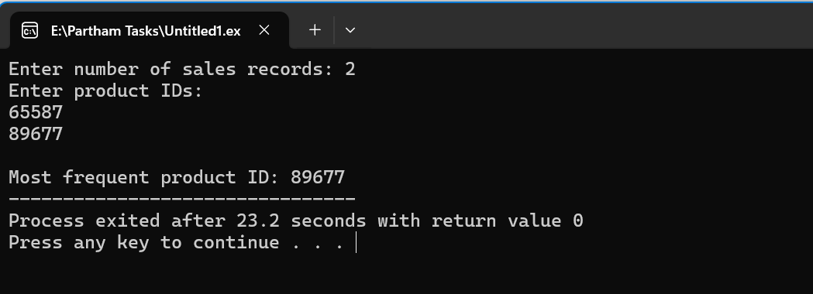

**Question 05**

* **Code**

#include <stdio.h>

int main() {

int n, budget;

printf("Enter number of items: ");

scanf("%d", &n);

int prices[100];

printf("Enter item prices:\n");

for (int i = 0; i < n; i++) {

scanf("%d", &prices[i]);

}

printf("Enter customer's budget: ");

scanf("%d", &budget);

int found = 0;

for (int i = 0; i < n; i++) {

int remaining = budget - prices[i];

for (int j = i + 1; j < n; j++) { // <-- note: we can't avoid a double loop logically here

if (prices[j] == remaining) {

printf("\nItems found: %d and %d", prices[i], prices[j]);

found = 1;

break;

}

}

if (found) break;

}

if (!found)

printf("\nNo two items match the budget.");

return 0;

}

**Output**

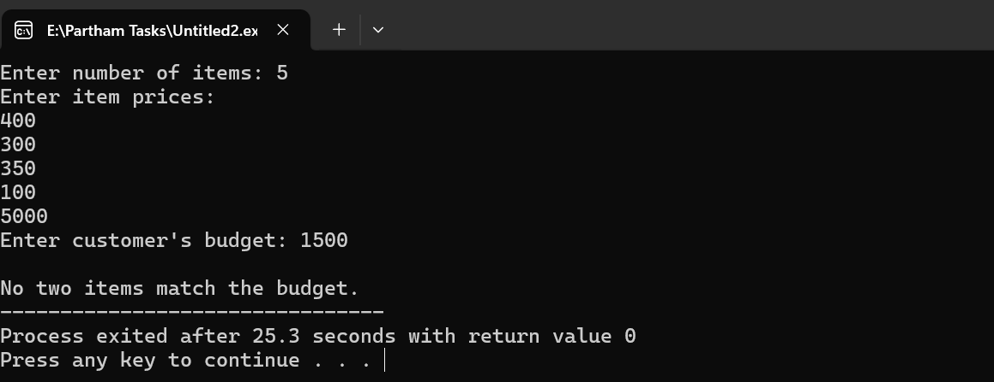

**Question 06**

* **Code**

#include <stdio.h>

int main() {

int n, x;

printf("Enter number of items: ");

scanf("%d", &n);

int arr[100];

printf("Enter item codes:\n");

for (int i = 0; i < n; i++) {

scanf("%d", &arr[i]);

}

printf("Enter defective item code to remove: ");

scanf("%d", &x);

printf("\nUpdated item list:\n");

for (int i = 0; i < n; i++) {

if (arr[i] != x)

printf("%d ", arr[i]);

}

return 0;

}

**Output**

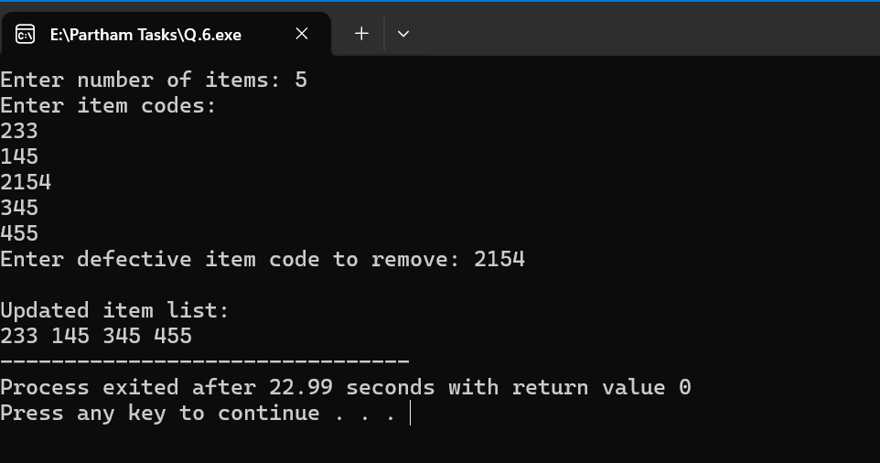

**Question 07**

* **Code**

#include <stdio.h>

int main() {

int n1, n2;

printf("Enter number of students in Section A: ");

scanf("%d", &n1);

int A[50];

printf("Enter roll numbers of Section A:\n");

for (int i = 0; i < n1; i++) {

scanf("%d", &A[i]);

}

printf("Enter number of students in Section B: ");

scanf("%d", &n2);

int B[50];

printf("Enter roll numbers of Section B:\n");

for (int i = 0; i < n2; i++) {

scanf("%d", &B[i]);

}

int merged[100];

for (int i = 0; i < n1; i++)

merged[i] = A[i];

for (int i = 0; i < n2; i++)

merged[n1 + i] = B[i];

printf("\nCombined list of roll numbers:\n");

for (int i = 0; i < n1 + n2; i++)

printf("%d ", merged[i]);

return 0;

}

**Output**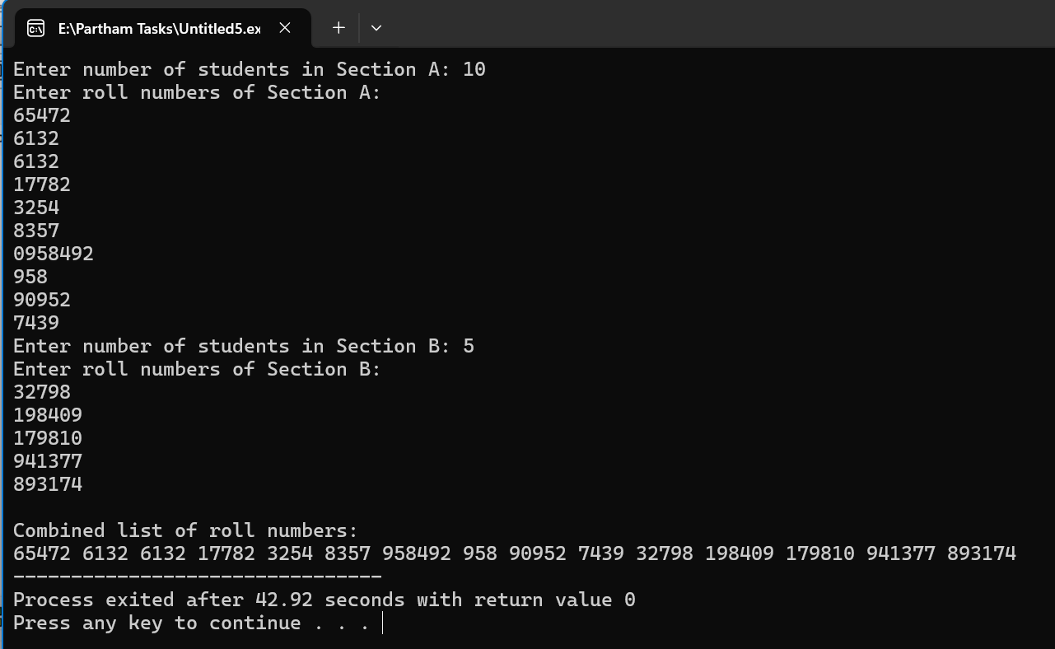

**Question 08**

* **Code**

#include <stdio.h>

int main() {

int n, k;

printf("Enter number of employees: ");

scanf("%d", &n);

int arr[100];

printf("Enter employee IDs:\n");

for (int i = 0; i < n; i++) {

scanf("%d", &arr[i]);

}

printf("Enter number of rotations (k): ");

scanf("%d", &k);

k = k % n;

int rotated[100];

int index = 0;

for (int i = n - k; i < n; i++)

rotated[index++] = arr[i];

for (int i = 0; i < n - k; i++)

rotated[index++] = arr[i];

printf("\nArray after right rotation:\n");

for (int i = 0; i < n; i++)

printf("%d ", rotated[i]);

return 0;

}

**Output**

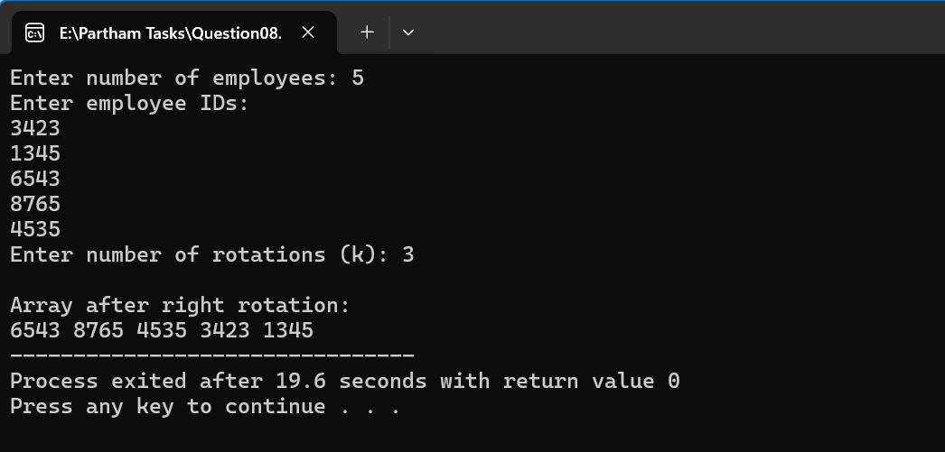

**Question 09**

* **Code**

#include <stdio.h>

int main() {

int seats[10] = {0};

int booked = 0, seat;

while (booked < 5) {

printf("\nEnter seat number (0-9): ");

scanf("%d", &seat);

if (seat < 0 || seat > 9) {

printf("Invalid seat number.\n");

continue;

}

if (seats[seat] == 0) {

seats[seat] = 1;

booked++;

printf("Seat booked successfully!\n");

} else {

printf("Seat already booked.\n");

}

}

printf("\nFinal seat status (1=booked, 0=empty):\n");

for (int i = 0; i < 10; i++)

printf("%d ", seats[i]);

return 0;

}

**Output**  
  
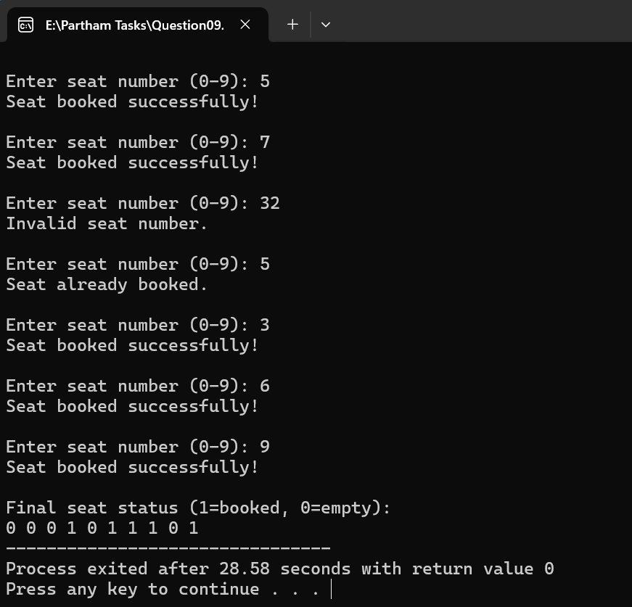

**Question 10**

* **Code**

#include <stdio.h>

#include <stdlib.h>

#include <time.h>

int main() {

int arr[10];

srand(time(0));

printf("Generated 10 random numbers:\n");

for (int i = 0; i < 10; i++) {

arr[i] = rand() % 100; // random numbers 0–99

printf("%d ", arr[i]);

}

int search;

printf("\n\nEnter number to search: ");

scanf("%d", &search);

for (int i = 0; i < 10; i++) {

if (arr[i] == search) {

printf("Number found at index %d.\n", i);

return 0;

}

}

printf("Number not found in the list.\n");

return 0;

}

**Output**

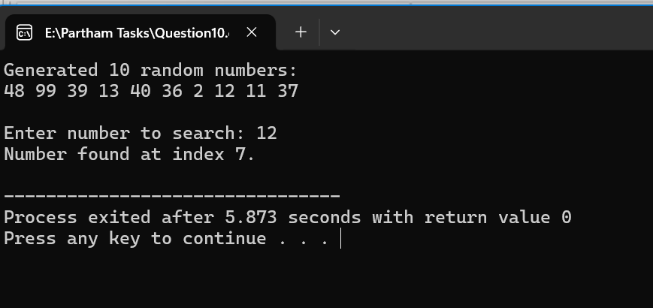

**GitHub Repository Link**

[**https://github.com/varooonkumar/Pf-Lab-07-Remaining-Task.git**](https://github.com/varooonkumar/Pf-Lab-07-Remaining-Task.git)